**Trello: Getting Started - Session 1**

During this session, the focus was on familiarizing yourself with Trello, encompassing tasks such as initiating and configuring Trello, exploring its interface, setting up a new project on the dashboard, and acquainting myself with its diverse features.

**Setting Up Trello:**

Trello is available **both online and as a desktop app**. We can access the online version at <https://trello.com/> or download the app for our operating systems.

**Online Version:**

1. **Create a free account** using our email addresses or sign in conveniently with Google or Apple.
2. Dashboard of Trello
   Upon logging in, we'll land on our **dashboards**, the central hubs for accessing and managing all our projects and boards.

**Desktop Version:**

1. **Download and install** the Trello app for our systems.
2. **Launch the app** and sign in using our existing Trello account credentials.

I used the online version of Trello as it was easy to access and did not take any disk space in my PC. It also saved us from the hassle of the installation on the PC.

**Navigating the Interface:**

Both interfaces share a similar layout with intuitive toolbars for easy navigation. Let's explore some key elements:

* **Top Bar:** This bar displays our names, notifications, and provides quick access to settings and account management. We can also search for specific boards, members, or power-ups (additional functionalities) from here.



* **Board Menu:** Located on the left side of the screen, this menu houses our existing boards and allows us to **create new ones** to organize our projects effectively.
* 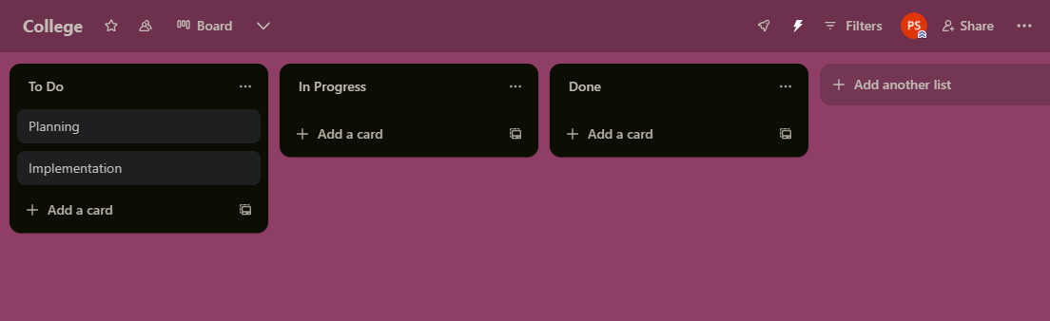**Card Menu (within a board):** This menu appears on the right side of the board and provides options for adding new lists, cards, and power-ups specific to that board, enabling us to customize our workflows.
* A screenshot of a computer

  Description automatically generated**Card Actions:** Each card, representing individual tasks within our projects, has its own set of actions. We can add checklists for breaking down complex tasks, labels for categorization, comments for team collaboration, attachments like files or images for reference, and due dates to ensure timely completion.
* A screenshot of a computer

  Description automatically generated­**Creating Our First Project:**

1. Click on the "**Create new board**" button.
2. Give our boards **descriptive names** that reflect the projects' purposes, making them easy to identify and reference later.
3. Choose the "**Make it private**" option if we only want specific members to access and collaborate on the projects.
4. Click "**Create board**" to bring our projects to life on Trello.

**Exploring Trello's Features:**

Trello offers various features to manage our projects effectively:

* A screenshot of a computer

  Description automatically generated**Lists:** These represent different stages in our workflows, allowing us to visualize the progress of our tasks. We can add lists like "To Do," "In Progress," and "Done," and easily rename or rearrange them to suit our specific needs.

* 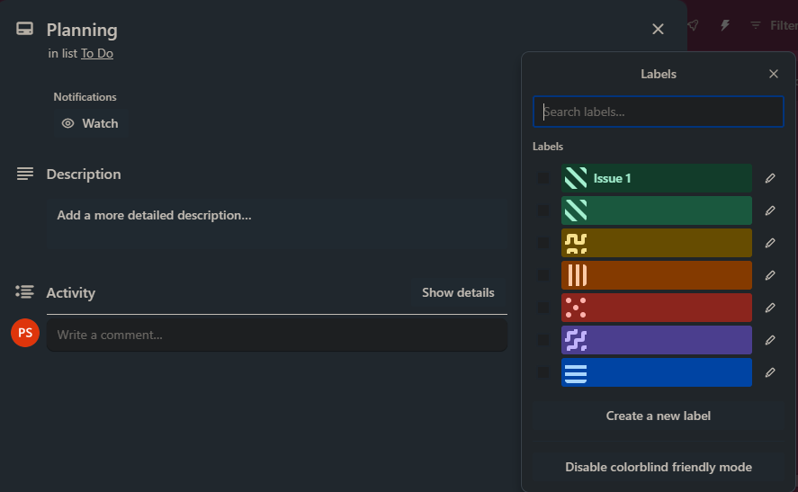**Cards:** Each card represents an individual task within our projects. We can add detailed descriptions, insightful comments for team discussions, relevant attachments, and helpful checklists to break down larger tasks into manageable steps, ensuring clarity and efficient execution.
* **Labels:** These colorful tags act as visual cues, allowing us to categorize cards for easy identification and filtering. Assign labels to prioritize tasks, highlight specific types of tasks, or categorize them based on different criteria.
* 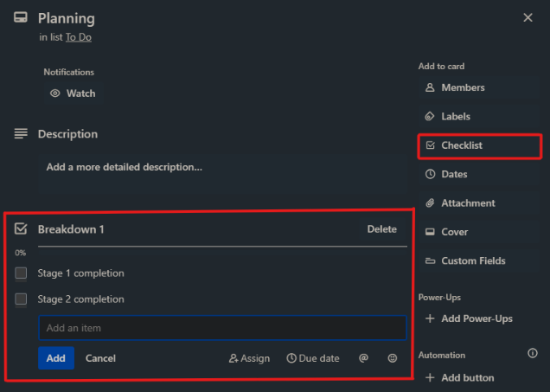**Checklists:** We can break a large task into smaller, actionable items within a card using checklists. This helps us stay focused, track progress, and achieve the larger goal efficiently.

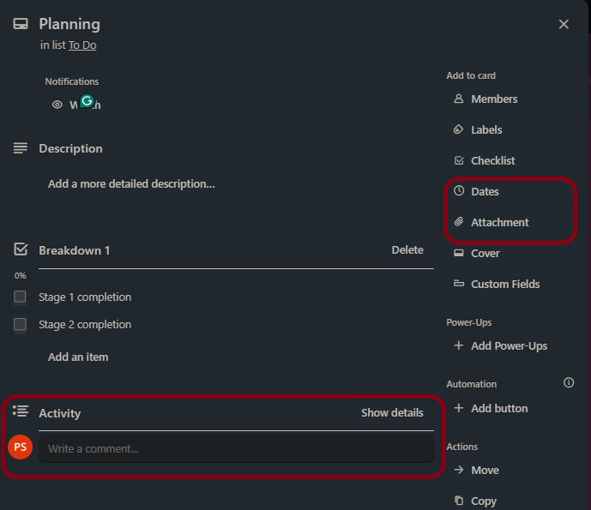

* **Comments:** Foster communication and collaboration within our teams by adding comments directly on specific cards. Discuss ideas, ask questions, provide updates, and keep everyone informed on the projects' progress.
* **Attachments:** Need to refer to a document, image, or other file for a specific task? Simply upload it as an attachment to the relevant card, keeping all essential information readily accessible for our teams.
* **Due Dates:** Set deadlines for cards to ensure timely completion of tasks, keeping our projects on track and meeting objectives.

This session provided a foundational understanding of setting up, navigating, and creating our first projects in Trello. We'll delve deeper into advanced features and explore various functionalities in subsequent sessions.

**Trello: Getting Started - Session 2: Defining and Creating the Project**

**Building upon the fundamentals of setting up and navigating Trello, this session dives deeper into effectively defining and creating our projects.**

**Understanding Project Information:**

* 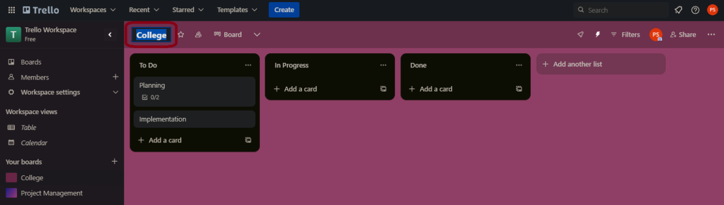**Board Title:** Clearly define the project's purpose in the board title for easy identification and reference. This helps everyone on the team understand what the project is about briefly.

* **Description:** Provide a concise yet informative description outlining our project's goals, scope, and key deliverables in the board description section. This provides context and helps team members stay aligned on the project's objectives.

**Calendar, Time, and Labels:**

* **Calendar Power-Up:** Enhance our project management by integrating a calendar power-up like "Calendar for Trello" or "Timelines for Trello." These power-ups enable visualization of deadlines and project progress within the Trello interface.

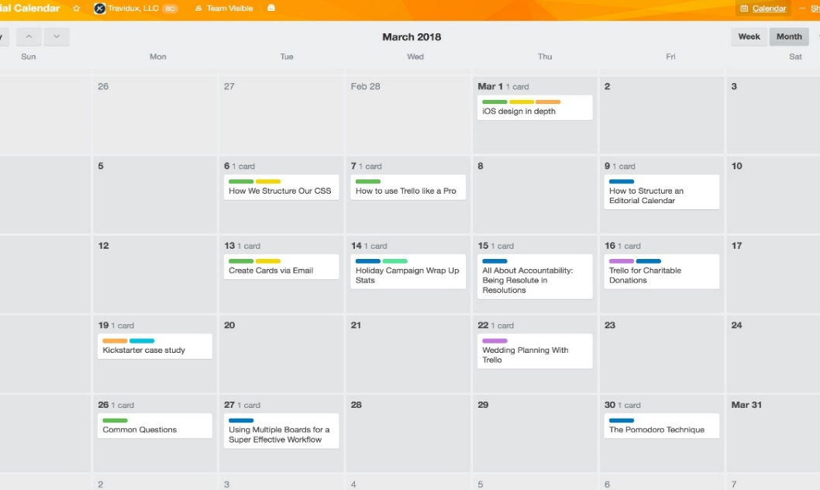

* **Due Dates:** Assign due dates to individual cards to establish deadlines and ensure timely task completion. This helps team members stay focused and meet deadlines.

**Status:**

* **Customize Statuses:** Trello offers default statuses ("To Do," "In Progress," "Done") for cards. We can further customize these by adding new board-specific statuses through the "List Menu" on the right side of the board. This allows us to tailor the workflow to our specific project needs.

**Creating a Calendar:**

1. Navigate to the "Power-Ups" menu on our board and search for our chosen calendar power-up (e.g., "Calendar for Trello").
2. Install and activate the power-up according to the provider's instructions.
3. Access the power-up menu in the board interface. From there, we can create calendars, set working/non-working days, and link calendars to the Gantt chart if needed.

**Setting Working and Non-Working Days:**

1. Access our chosen calendar power-up's menu within the Trello board.
2. Look for settings related to working days and non-working days.
3. Define our workweek by selecting the days we consider working and non-working days (e.g., weekends, holidays). This ensures accurate scheduling and task visualization within the calendar.

**Applying Calendar to Gantt Chart:**

**Note:** Not all calendar power-ups offer built-in Gantt chart functionalities.

1. If our chosen power-up offers a Gantt chart feature, locate the relevant section within the power-up's menu.
2. We'll likely find options to link the calendar events (representing tasks) to the Gantt chart, enabling a visual representation of the project schedule and dependencies.

**Linking Tasks:**

1. Open the card representing the task we want to link.
2. Look for the "Link" option within the card menu or actions.
3. Choose "Link to another card" and select the card we want to establish a connection with. This allows visualization of task dependencies and relationships within our project, improving communication and collaboration.

**Things to Remember:**

* Explore our chosen calendar power-up's specific functionalities and settings for detailed instructions.
* Utilize labels, statuses, and due dates effectively to maintain project clarity, organization, and focus.

By understanding and applying these elements, we can confidently define and create our projects in Trello, fostering efficient project management and successful execution.

**Trello: Getting Started - Session 3: Creating Tasks**

This session equips us with the skills to effectively create, manage, and organize tasks within our Trello projects.

**Entering Tasks and Task Duration:**

1. **Adding Tasks:** Click on the "Add a card" button on any list within our board. A new card representing the task will appear.
2. **Entering Task Details:** We can enter a clear and concise description of the task within the card.
3. **Estimating Task Duration:** While Trello doesn't have built-in time tracking, we can estimate the time required to complete the task by adding a custom field (available through Power-Ups) like "Estimated Time" or "Time to Complete." Alternatively, we can mention the estimated duration within the task description itself (e.g., "Write report (2 hours)").

**Understanding Milestones and Phases:**

* **Milestones:** These represent significant achievements or deliverables within our project. We can create separate lists for milestones to track progress and celebrate achievements.
* **Phases:** Think of phases as broader stages within our project (e.g., Planning, Development, Testing). Let's utilize separate lists for each phase to visualize the workflow.

**Inserting, Editing, Moving, Changing, and Deleting Tasks:**

* **Inserting Tasks:** As mentioned earlier, we can use the "Add a card" button to create new tasks within relevant lists.
* **Editing Tasks:** Let's click directly on the card title or description to edit the details of a task.
* **Moving Tasks:** We can simply drag and drop cards between lists to signify progress or re-prioritization.
* **Changing Statuses:** Let's utilize the card menu to change the status of a task (e.g., "To Do" to "In Progress" or "Done").
* **Deleting Tasks:** We can open the card menu and select "Archive Card" to remove it from the board. Archived cards can still be accessed if needed.

**Arranging Tasks Using Priority:**

* **Labels for Priority:** Let's assign colored labels (e.g., red for high priority, yellow for medium) to tasks to visually indicate their importance.
* **List Positioning:** We can prioritize tasks by positioning relevant lists at the top of our board.

**Linking Tasks:**

1. Let's open the card representing the dependent task.
2. We need to locate the "Link" option within the card menu or actions.
3. Choose "Link to another card" and select the card it depends on. This establishes a visual connection between linked tasks, improving project clarity.

By mastering these techniques, we can create well-defined tasks, structure our workflow effectively, and prioritize efficiently within Trello, ensuring everyone on the team is on the same page.

**Trello: Getting Started - Session 4: Scheduling**

This session delves into scheduling techniques within Trello, helping us visualize project timelines and identify critical tasks.

**Understanding Lead Time and Lag Time:**

* **Lead Time:** The time it takes to begin a dependent task after the completion of a preceding task. For example, if Task B cannot start until Task A is finished, the lead time is the duration between Task A's completion and Task B's commencement.
* **Lag Time:** The amount of time a dependent task can be delayed without impacting the overall project schedule. In essence, it's the flexibility in scheduling the dependent task.

**Understanding Gantt Chart and Network Diagram View:**

Trello doesn't offer built-in Gantt charts or network diagrams. However, by utilizing calendar power-ups like "Calendar for Trello" or "Timelines for Trello," we can achieve similar functionalities:

* **Gantt Chart:** A bar chart that visually represents the project schedule, with tasks depicted as horizontal bars along a timeline. The length of each bar reflects the task's duration.
* **Network Diagram View:** A graphical representation of the project schedule, showcasing task dependencies using arrows and nodes. Arrows depict the relationships between tasks, with the node representing the task itself.

**Examining Network Diagram:**

While not directly available in Trello, understanding network diagrams is valuable for scheduling. Imagine a network diagram as a flowchart, where tasks are represented by boxes and arrows depict the sequence or dependencies between them.

By analyzing the network diagram, we can identify the critical path.

**Setting the Critical Path:**

* **Critical Path:** The longest sequence of dependent tasks in a project that directly impacts the overall deadline. Delays in any tasks along the critical path will cause a delay in the entire project.

**Important Note:**

While Trello itself may not have built-in Gantt charts or network diagrams, integrating calendar power-ups with these functionalities can significantly enhance our scheduling capabilities.

By grasping these concepts, we can effectively schedule tasks within Trello, identify critical paths, and ensure our projects stay on track.

**Trello: Getting Started - Session 5: Cost Management**

This session explores cost management strategies using Trello and delves into how Microsoft Excel can be a powerful companion tool.

**1. Managing Total Cost for Tasks and Resources:**

* **Trello:** While Trello doesn't have built-in cost tracking features, we can leverage custom fields (available through Power-Ups) to estimate and track task-specific costs. For example, we can create a custom field named "Cost" and enter the estimated cost for each task within the card description.
* **Excel:** Excel offers robust functionalities for cost management. Create a spreadsheet with columns for tasks, resources (materials, labor), and corresponding costs. Utilize formulas to calculate total task costs and overall project budget.

**2. Managing the Total Cost of the Project:**

* **Trello:** Utilize custom fields (as mentioned earlier) to track task costs. Summing these individual task costs will provide an estimate of the total project cost.
* **Excel:** Consolidate cost data from various tasks and resources within your spreadsheet. Employ formulas like SUM to calculate the total project cost, providing a clear financial overview.

**3. Managing Cost Variance for Tasks, Resources, and Assignments:**

* **Trello & Excel:** Both Trello (custom fields) and Excel allow us to track actual costs incurred for tasks and resources. By comparing these actual costs with the initial estimates, we can calculate cost variances (positive or negative) for individual tasks, resources, and assignments. This variance analysis helps identify areas for budget optimization and cost control.

**4. Cost-Benefit Analysis, Calculating IRR, Present Value, and Future Value, Cash Flow Forecast:**

While Trello isn't designed for complex financial calculations, Excel excels in this domain.

* **Cost-Benefit Analysis:** Evaluate the project's financial viability by comparing its projected costs with the anticipated benefits. Utilize Excel's functions and charts to create a cost-benefit analysis report.
* **IRR (Internal Rate of Return):** Calculate the IRR, which is the discount rate that makes the net present value of all cash flows from a project equal to zero. Excel's built-in IRR function simplifies this calculation.
* **Present Value (PV) and Future Value (FV):** Determine the present value (discounted worth) of future cash flows or the future value (grown amount) of an investment using Excel's PV and FV functions.
* **Cash Flow Forecast:** Project future cash inflows and outflows associated with the project using a cash flow forecast spreadsheet in Excel. This helps with financial planning and risk management.

**Remember:** Trello provides a flexible platform for task management and basic cost tracking. However, for in-depth financial analysis and calculations, Excel proves to be a powerful companion tool. By effectively utilizing Trello and Excel, we can gain valuable insights into project costs, optimize budgets, and make informed financial decisions.

**Trello: Getting Started – Session 6: Effort Estimation**

This session tackles effort estimation, a crucial aspect of project planning, within Trello and explores how Excel can complement this process.

**1. Managing Task Effort:**

* **Trello:** While Trello doesn't have built-in time tracking, we can leverage various techniques to estimate and manage task effort:
  + **Time Estimates in Descriptions:** Include estimated time for completion directly within the task description (e.g., "Write report (2 hours)").
  + **Custom Fields:** Utilize custom fields (available through Power-Ups) like "Estimated Effort" or "Time to Complete" to quantify effort for each task.
  + **Story Points:** Implement a story point system (popular in Agile methodologies) to assign relative effort values to tasks. Assign points based on complexity, not actual time (e.g., 1 point for simple tasks, 5 points for complex tasks).
* **Excel:** Create a spreadsheet listing tasks and dedicate columns for estimated effort (hours, days, story points). Utilize this data to track individual task effort.

**2. Managing the Total Effort of the Project:**

* **Trello:**
  + **Sum of Task Estimates:** If using time estimates in descriptions, manually sum the estimated times for all tasks to arrive at an overall project effort estimate.
  + **Custom Field Calculations:** For custom fields with numerical effort values, utilize the "Card Butler" Power-Up to create formulas that automatically calculate the total project effort by summing individual task effort values.
  + **Story Points:** When using story points, estimate the team's overall capacity (e.g., story points completed per sprint) and compare it to the total project story points to assess feasibility.
* **Excel:** Consolidate task-level effort data from your spreadsheet. Employ formulas like SUM to calculate the total project effort, providing a high-level view of the overall workload.

**Remember:** Trello offers basic effort estimation functionalities, while Excel allows for more complex calculations and visualizations.

By effectively managing task and project effort in Trello and Excel, we can create realistic project timelines, allocate resources efficiently, and avoid scope creep.